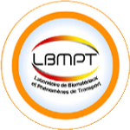

The First National Conference on
Green Process Engineering and
Environmental Technologies.
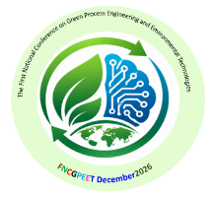

FNCGPEE December 2026

Regestration form

(to be completed and returned by e-mail before le 10/11/2026)

Nom et prénom: ……………………………………………………………………………..
Fonction: …………………………………………………………………………………….
Organisme: …………………………………………....………………………………………
Adresse: ……………………………………………………………………………………..
Ville: ……………………………………………………
Tél : ……………………………………………………
E-mail: ……………………………………………………

Thématique :
Track 1: Green Engineering and Sustainable Processes
Track 2: Water and Wastewater Treatment
Track 3: Advanced separation and Artificial Intelligence
Track 4: Renewable Energy

Intitulé de la communication : ....……………………………………………………………

…………………………………………………………………………………………………
Préférence de la présentation : Communication orale Communication affichée (Poster)

